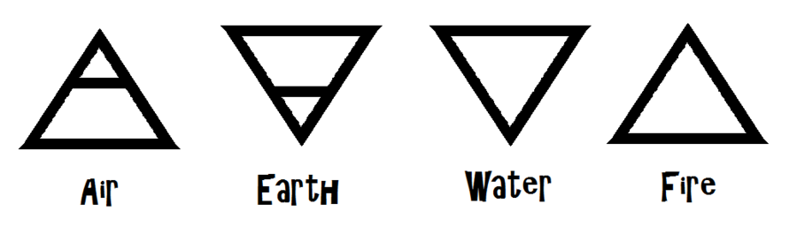

BIO 101 Final Project - “Cooked”

Michael Pollan’s Cooked is divided into four chapters based on the four classic elements: Fire, Air, Water and Earth. In these chapters you learned about grilling with fire, braising (water), baking bread (air) and fermenting food (earth). For your final project you are to “cook” using one of the four elements outlined in the book. I have narrowed down the possibilities and have researched some simple, basic recipes for you to use. You may choose your own recipe for this project as well, but it needs to be reviewed by me beforehand.

Please choose one of the following topics:

Air
Bread making

Water
Braising (making Sugo aka Ragu or Bolognese sauce)

Earth
Cheese making
Sauerkraut
Kimchi
Beer making (if you are 21 and can prove it )
* will require purchasing a beer making kit

Fire
Pork Shoulder Barbecue or any BBQ recipe that involves similar techniques as outlined on pages 418-420 in Cooked.
* this choice is a little more complicated than your other choices….if your up to the
challenge than go for it!

You will be writing a modified lab report for your project documentation. Please follow the instructions below.

Lab Report Format

Reports must be typed (12 font, double spaced): no handwritten reports will be accepted; reports should be entirely in YOUR OWN WORDS! Use proper reference methods if you paraphrase. Write in complete sentences and in paragraph form. Do not list materials or methods or observations using dots, dashes, or numbers. Use ONLY the subtitles given in the outline below; do not further subdivide your report. Write in the PAST TENSE: you are writing about an experiment already performed/completed. Write in the ACTIVE VOICE use (I, me, or we). Write clearly and concisely, using proper grammar and spelling.
The purpose of writing a lab report is to determine how well you performed your experiment, how much you understood what happened during the experimentation process, and how well you can convey that information in an organized fashion.

TITLE PAGE:
Your name, section number, instructor’s name, date, and title of the experiment.
Title: The title says what you did. It should be brief (aim for ten words or less) and describe the main point of the experiment or investigation. An example of a title would be: "Effects of Ultraviolet Light on Borax Crystal Growth Rate". If you can, begin your title using a keyword rather than an article like 'The' or 'A'.

>Introduction
>Methods
>Results
>Analysis/Discussion
>Conclusion

Introduction:
Define the topic. The first part of a lab report should set up the topic being investigated by providing background information on it and clearly explaining exactly what you are testing. This is where the ‘biology’ comes in. The introduction should include any background information needed for the reader to understand what happened. This includes the science behind the cooking (chemical reactions, etc)…..why does the meat turn brown? What are the microbes actually doing to the cabbage when you make sauerkraut, etc.
Explain the significance of the topic. How does this topic relate to the world of biology? Why is this experiment topic important? Why is this experiment important? Essentially, you should describe why your audience should pay attention to this experiment.
Define the overall goal. Not all scientific studies have a hypothesis; the scientist just wants to obtain more information and/or make an observation. You do not need to state a hypothesis but you will need to state a goal for this exercise. This goal should be clearly defined and explained.

Methods:
Explain what steps were taken in performing the experiment. This is the section where you describe the procedures you used in conducting the experiment.
Use the narrative format. This section should not be in a list format or read like a recipe. The information should be relayed in a story type of writing.
Only include the important details. Not every detail needs to be included. Only the relevant elements should be mentioned. If a scientist would need to know a certain aspect to repeat the experiment, then it should be included. Otherwise, leave it out.
Results:

This section will be very brief. Simply explain in words what your results were. You can include a picture of your end product if you wish. Remember to use descriptive words when describing your end product.
Appearance
Color
Exterior condition/ Interior condition
Aroma
Intensity
Off-notes of aroma
Clean, ammoniated, barnyard, grassy, particular odor, etc
Flavor
Basic Taste:
Sweet, sour, salty, bitter, flat, acidic, metallic, rancid, malty, whey-like, yeast-like, unclean, scorched, “barnyardy”
Intensity of flavor (low, medium, high)
Texture- Soft, Firm, Tender, Tough, Short, Long, Smooth, Gritty, Chewy, Springy, Elastic, Gooey, Cohesive, Pliable, Brittle, Flaky , etc
Do NOT discuss the implications of the results in this section, nor attempt to explain why various results occurred.

Discussion:
This section carries the most weight. This is where you interpret what you have discovered. The reader needs to know what the results of the experiment mean. Interpret and discuss your data and relate your results to the background information from the introduction section of your report. Explain WHY you think you obtained the results that you did.
Discuss significant experimental errors that may have caused unexpected results. This section is your chance to demonstrate how well you understood your techniques and results and to use your critical thinking skills.
This is also where you would discuss any mistakes you might have made while conducting the investigation. You may wish to describe ways the experiment might have been improved.

Conclusion:

What part of this exercise stood out to you? Why?
What one new fact did you learn from conducting this exercise?
What one new fact did you learn from reading this book?
What life lesson can be learned from this exercise?
Did this exercise change your thoughts about cooking in a positive or negative way? Explain.
Choose one science-based concept learned from this exercise. How is this related to what we are studying in this course?
Michael Pollan states “To learn to cook is to put yourself on intimate terms with the laws of physics and chemistry, as well as the facts of biology and microbiology.”
Do you agree? Why? Why not?......Explain.

